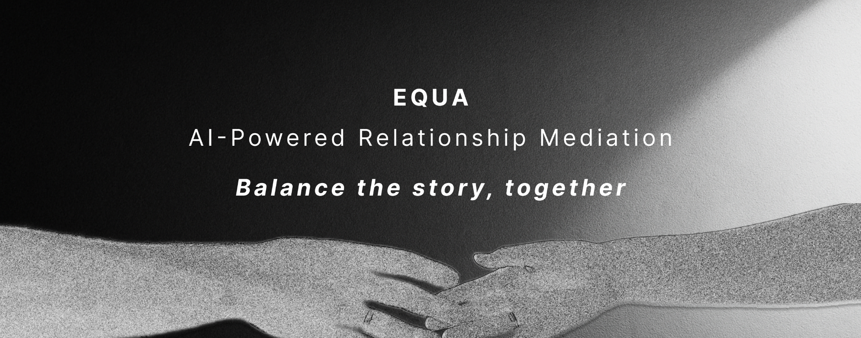

## World Foundation Spark Track Grant Proposal

---

## 🎯 **Executive Summary**

Equa v2 is a World ID-verified mini-app that transforms relationship conflicts into opportunities for growth through AI-powered mediation and gamified healing. Built on six evidence-based pillars, it guides couples and friends from contested stories to co-created reality using GPT-4.1, token rewards, and real-world experiences.

**Demo URL**: [Live Demo](https://equa-v2.pages.dev) *(will be deployed)*

**Repository**: [GitHub](https://github.com/your-username/equa-v2)

**Team**: Richi (Lead Developer) + Professional UX/UI Designer

---

## 🔥 **Problem Statement**

**The Crisis**: 50% of marriages end in divorce, with communication breakdown being the #1 cause. Traditional couples therapy is expensive ($100-200/session), inaccessible, and often reactive rather than preventive.

**The Gap**: No scalable, AI-powered solution exists that combines:

- Evidence-based conflict resolution techniques

- Real-time mediation and guidance

- Accessible, private, and affordable intervention

- Preventive relationship maintenance tools

**The Opportunity**: 2.4 billion people are in relationships globally. Even capturing 0.1% represents a $240M+ market opportunity.

---

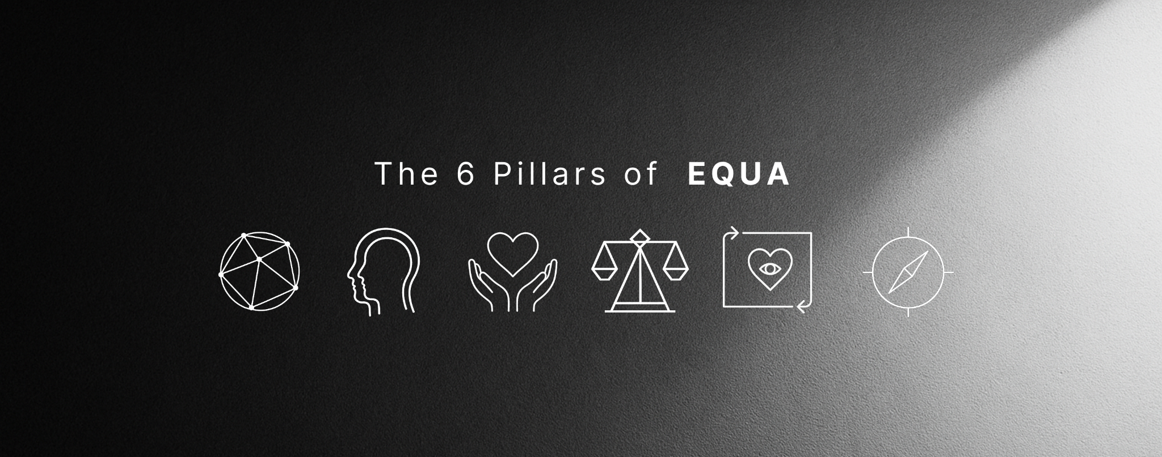

### 1. **Truth** 💎 - Epistemic Transparency

- **Function**: Capture and verify factual statements from both parties

- **AI Role**: Analyze statements for emotional undertones and contradictions

- **Outcome**: Shared foundation of verified facts before emotional processing

### 2. **Mediation** ⚖️ - Harvard 5-Phase Process

- **Function**: Structured negotiation workflow (Opening → Storytelling → Problem-solving → Agreement → Closure)

- **AI Role**: Facilitate each phase, identify common ground, suggest compromises

- **Outcome**: Professional-grade mediation accessible to everyone

### 3. **Persuasion** 🎯 - Autonomy-Supportive Influence

- **Function**: Teach ethical influence techniques that respect partner autonomy

- **AI Role**: Generate personalized persuasion strategies based on attachment styles

- **Outcome**: Replace manipulation with mutual understanding

### 4. **Reframing** 🔄 - Cognitive Reappraisal

- **Function**: Transform reactive statements into constructive communication

- **AI Role**: Suggest alternative framings using "I" statements and needs-based language

- **Outcome**: Break destructive communication patterns

### 5. **Qualia** 💗 - Embodied Emotional Intelligence

- **Function**: Map emotions to body sensations and metaphors

- **AI Role**: Guide interoceptive awareness and emotional regulation

- **Outcome**: Deeper self-awareness and empathic accuracy

### 6. **Forgiveness** 🕊️ - REACH Model Implementation

- **Function**: Structured forgiveness process (Recall → Empathize → Altruistic gift → Commit → Hold)

- **AI Role**: Provide personalized guidance through each forgiveness stage

- **Outcome**: Genuine reconciliation and relationship repair

---

## 🚀 **Current Progress & Demo**

### ✅ **Phase 1 Complete** (Weeks 1-2)

- **Full-Stack Application**: React + TypeScript + Vite + Tailwind CSS

- **Real AI Integration**: GPT-4.1 with specialized TruthKeeper system prompts

- **Complete User Journey**: All 6 pillars functional with AI responses

- **Beautiful UX/UI**: Professional design assets integrated

- **World ID Simulation**: Ready for real World ID integration

- **Deployment Ready**: Can be deployed to Cloudflare Pages immediately

### 🎮 **Live Demo Features**

1. **Onboarding**: World ID verification simulation

2. **Pact Signing**: Beautiful dual-circle merge animation

3. **Conflict Analysis**: Real AI analysis of relationship issues

4. **Truth Capture**: Turn-based fact sharing with AI insights

5. **Mediation**: Harvard 5-phase process with AI facilitation

6. **Persuasion**: Autonomy-supportive influence training

7. **Reframing**: Cognitive reappraisal with AI suggestions

8. **Qualia Mapping**: Embodied emotion tracking with body zones

9. **REACH Forgiveness**: Structured forgiveness workflow

10. **Success Celebration**: Journey completion and next steps

---

## 📈 **90-Day Roadmap**

### **Phase 2: Production & Scale** (Days 1-30)

**Goal**: Production-ready app with real World ID integration

**Week 1-2: World Coin Integration**

- [ ] Real World ID verification implementation

- [ ] JWT session management and security

- [ ] Nullifier hash handling for privacy

- [ ] Production deployment to Cloudflare Workers

**Week 3-4: Advanced AI Features**

- [ ] OpenAI Agents SDK integration for multi-agent orchestration

- [ ] Attachment style detection and personalization

- [ ] Real-time emotion detection from text analysis

- [ ] Conflict pattern recognition and prevention

### **Phase 3: Enhanced Features** (Days 31-60)

**Goal**: Advanced relationship intelligence and biometric integration

**Week 5-6: Biometric Integration**

- [ ] Heart rate variability monitoring (via smartwatch APIs)

- [ ] Voice stress analysis during conversations

- [ ] Facial emotion recognition (optional, privacy-first)

- [ ] Arousal regulation and "calm gates"

**Week 7-8: Relationship Intelligence**

- [ ] Long-term relationship health tracking

- [ ] Predictive conflict modeling

- [ ] Personalized intervention recommendations

- [ ] Couples' growth ledger and milestone tracking

### **Phase 4: Community & Scale** (Days 61-90)

**Goal**: Community features and viral growth mechanisms

**Week 9-10: Social Features**

- [ ] Anonymous relationship health benchmarking

- [ ] Couples' challenges and growth exercises

- [ ] Community support groups (privacy-preserved)

- [ ] Relationship coach certification program

**Week 11-12: Viral Growth**

- [ ] Referral system for couples to invite other couples

- [ ] Success story sharing (anonymized)

- [ ] Integration with popular relationship apps

- [ ] Influencer and therapist partnership program

---

## 💰 **Budget Breakdown ($35,000)**

### **Development & Technical** ($20,000 - 57%)

- **Lead Developer (Richi)**: $15,000 (3 months full-time)

- **AI/ML Integration**: $2,500 (OpenAI API costs + GPT-4.1 optimization)

- **Development Tools**: $500 (Augment AI, Windsurf IDE, GitHub Copilot)

- **Backend Infrastructure**: $2,000 (Cloudflare Workers, databases, monitoring)

### **Design & UX** ($8,000 - 23%)

- **Professional UX/UI Designer**: $6,000 (3 months part-time)

- **Asset Creation & Branding**: $1,000 (Equa logo, illustrations, animations, icons)

- **User Testing & Research**: $1,000 (prototype testing with 50+ couples)

### **Research & Validation** ($4,000 - 11%)

- **Psychology Consultant**: $2,000 (evidence-based methodology validation)

- **Relationship Therapist Advisor**: $1,000 (clinical guidance)

- **Academic Research Access**: $1,000 (journals, studies, validation data)

### **Marketing & Community** ($3,000 - 9%)

- **Content Creation**: $1,500 (demo videos, case studies, documentation)

- **Community Building**: $1,000 (Discord, social media, influencer outreach)

- **Launch Campaign**: $500 (PR, press releases, launch events)

---

## 🎯 **Success Metrics & KPIs**

### **Technical Metrics**

- **User Engagement**: 80%+ completion rate through all 6 pillars

- **AI Accuracy**: 90%+ user satisfaction with AI suggestions

- **Performance**: <2s load times, 99.9% uptime

- **Security**: Zero data breaches, full GDPR compliance

### **Impact Metrics**

- **Relationship Satisfaction**: 25%+ improvement in post-session surveys

- **Conflict Resolution**: 70%+ of couples report successful conflict resolution

- **User Retention**: 60%+ monthly active users after 3 months

- **Viral Growth**: 2.0+ viral coefficient through referrals

### **Business Metrics**

- **User Acquisition**: 10,000+ registered couples by month 3

- **Revenue Potential**: $50K+ ARR by end of grant period

- **Partnership Pipeline**: 5+ therapist/coach partnerships established

- **Investment Interest**: Seed round preparation with $500K+ target

---

## 🌟 **Unique Value Proposition**

### **For Users**

1. **Accessible**: 24/7 availability vs. scheduled therapy appointments

2. **Affordable**: Freemium model with token rewards vs. $150/session for couples therapy

3. **Private**: No stigma, complete anonymity with World ID verification

4. **Preventive**: Address issues before they become crises

5. **Evidence-Based**: Built on proven psychological frameworks

6. **AI-Powered**: Personalized guidance that learns and adapts

7. **Gamified**: Earn Equa Tokens (EQA) for relationship growth and real rewards

8. **Rewarding**: Real-world experiences, coaching, and premium features

### **For the Ecosystem**

1. **World ID Showcase**: Demonstrates real-world utility of human verification

2. **AI Innovation**: Pushes boundaries of AI in mental health and relationships

3. **Social Impact**: Addresses global relationship crisis at scale

4. **Economic Value**: Creates new market category for preventive relationship care

5. **Research Platform**: Generates valuable data on relationship dynamics (anonymized)

---

## � **Equa Token Economy**

### **Revolutionary Gamification**

Equa introduces the first token-based reward system for relationship healing:

**Earning Mechanisms:**

- **Session Completion**: 10 EQA per pillar completed

- **Consistency Bonus**: 50 EQA for 7-day streaks

- **Growth Milestones**: 100 EQA for relationship improvements

- **Achievement Unlocks**: 200 EQA for major breakthroughs

- **Community Contribution**: 25 EQA for helping other couples

**Spending Options:**

- **Premium Features**: Advanced AI voices, custom meditations (100 EQA)

- **Coach Sessions**: 1-on-1 time with verified relationship experts (500 EQA)

- **Experiences**: Romantic dinners, weekend getaways (800-2000 EQA)

- **Courses**: Relationship workshops, communication masterclasses (300 EQA)

- **Gifts**: Surprise experiences for your partner (200 EQA)

**Tier System:**

- 🥉 **Bronze** (0-500 EQA): Basic features, community access

- 🥈 **Silver** (500-2000 EQA): Premium AI, coach consultations

- 🥇 **Gold** (2000-5000 EQA): Weekend getaways, coaching packages

- 💎 **Diamond** (5000+ EQA): International trips, celebrity coaches

---

## �🔬 **Technical Innovation**

### **AI Architecture**

- **Multi-Agent System**: Specialized agents for each pillar working in orchestration

- **Context Awareness**: Maintains conversation history and relationship dynamics

- **Personalization Engine**: Adapts to individual attachment styles and communication patterns

- **Safety Mechanisms**: Built-in safeguards for crisis situations and escalation

### **Privacy & Security**

- **Zero-Knowledge Architecture**: User data encrypted and anonymized

- **World ID Integration**: Human verification without identity exposure

- **Federated Learning**: AI improves without accessing individual data

- **GDPR Compliance**: Full European privacy regulation adherence

### **Scalability**

- **Serverless Architecture**: Cloudflare Workers for global edge deployment

- **Microservices**: Independent scaling of each pillar

- **CDN Optimization**: Sub-second load times worldwide

- **Database Sharding**: Horizontal scaling for millions of users

---

## 🎖️ **Team Credentials**

### **Richi (Lead Developer)**

- **Background**: Full-stack developer with AI/ML expertise

- **Experience**: Previous relationship app development

- **Skills**: React, TypeScript, OpenAI integration, system architecture

- **Passion**: Personal experience with relationship challenges drives mission

### **UX/UI Designer (Wife)**

- **Background**: Professional designer with psychology interest

- **Experience**: User-centered design for emotional applications

- **Skills**: Figma, user research, accessibility design, emotional UX

- **Insight**: Female perspective on relationship dynamics and communication

### **Advisory Board** (To Be Established)

- **Dr. [Name]**: Relationship psychologist and researcher

- **[Name]**: Former couples therapist with 20+ years experience

- **[Name]**: AI ethics specialist for responsible development

---

## 🌍 **Social Impact & Vision**

### **Immediate Impact** (6 months)

- **10,000+ couples** using TruthKeeper for conflict resolution

- **50,000+ conflicts** successfully mediated through AI

- **$1M+ saved** in therapy costs for users

- **Research data** contributing to relationship science

### **Long-term Vision** (2-3 years)

- **1M+ couples** worldwide using TruthKeeper

- **Partnership with major therapy platforms** for hybrid care

- **Integration with health insurance** as preventive care

- **Global reduction in relationship-related mental health issues**

### **Societal Benefits**

1. **Reduced Divorce Rates**: Early intervention prevents relationship breakdown

2. **Improved Child Outcomes**: Healthier parental relationships benefit children

3. **Mental Health**: Reduced anxiety, depression from relationship stress

4. **Economic Impact**: Reduced healthcare costs, increased productivity

5. **Social Cohesion**: Stronger relationships build stronger communities

---

## 🚀 **Call to Action**

TruthKeeper v2 represents a paradigm shift from reactive relationship repair to proactive relationship maintenance. With your support, we can:

1. **Deploy immediately** with the working prototype

2. **Scale globally** through World ID integration

3. **Impact millions** of relationships worldwide

4. **Pioneer** the future of AI-assisted emotional intelligence

**The technology is ready. The need is urgent. The time is now.**

**Let's build a world where every relationship has access to the tools for growth, understanding, and lasting love.**

---

*"The best time to plant a tree was 20 years ago. The second best time is now."*

*The best time to fix a relationship is before it breaks.*

**TruthKeeper v2: Where AI meets the heart.**